
Finanzi Corporate Services Limited
Docusign Envelope ID: 32CA3F6E-4964-4C40-9F5B-2436D035C371
Capital Business Centre,
Entrance A, Floor 1,
Triq Taz-Zwejt,
San Gwann, SGN3000
Malta

Company Reg No. C 89243
VAT No. MT2648 3907

Malta Business Registry
AM Business Centre
Triq il-Labour
Zejtun, ZTN 2401
Malta

Date: 17th December 2025

Approval for Registered Address

I, the undersigned, Daryl David Caruana, holder of Maltese ID Card Number 0103492M as director of Finanzi Corporate Services Limited, a company registered in Malta, with registration number C 89243 and registered office at Capital Business Centre, Entrance A, Floor 1, Triq Taz-Zwejt, San Gwann, SGN 3000, Malta (the ‘Administrator’) hereby give consent to Sweetflips Holdings Limited, a company to be registered under the laws of Malta (the ‘Company’), to utilize the office address of the Administrator, Capital Business Centre, Entrance A, Floor 1, Triq Taz-Zwejt, San Gwann, SGN 3000, Malta as the registered office of the Company with effect from date of incorporation.
I hereby confirm that I am aware that the Registrar of Companies and the Malta Business Registry shall not be held liable for any damages if the registered office of the Company is not altered after the termination of the consent. Furthermore, I confirm that I am aware that only an officer of the Company can alter the registered office of the Company.

Yours faithfully,

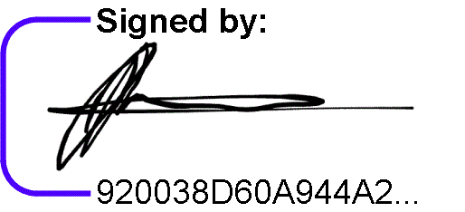
________________
Daryl David Caruana
Director
Finanzi Corporate Services Limited


www.finanzi.com.mt
info@finanzi.com.mt
(+356) 23889100

Date: 17th December 2025

Sweetflips Holdings Limited
Capital Business Centre
Entrance A, Floor 1
Triq Taz-Zwejt
San Gwann
SGN 3000
Malta

Dear Sirs,

I, the undersigned, Nick Johannes Martinus Steeghs, holder of Dutch Passport number NSJ3CJ3K1, hereby confirm my acceptance to act as Director and Company Secretary of Sweetflips Holdings Limited, a company to be registered in Malta, with proposed registered office situated at Capital Business Centre, Entrance A Floor 1, Triq Taz-Zwejt, San Gwann, SGN 3000, Malta with effect from the date of registration of the said company.

Yours faithfully,

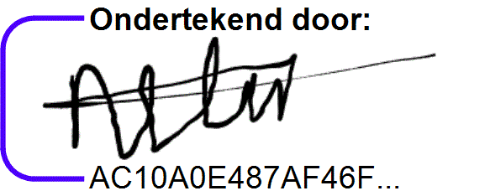
_____________________________
Nick Johannes Martinus Steeghs

POWER OF ATTORNEY

The undersigned, Amor Diego Muñoz Luis, a holder of Dutch passport number NT7K77236 and residing at 610, Meydan Grandstand, Meydan Road, 6th Floor, Dubai, UAE, hereby appoints Finanzi Corporate Services Limited with company registration number C 89243 and having its registered office at Capital Business Centre, Entrance A, Floor 1, Triq Taz-Zwejt, San Gwann, SGN 3000, Malta (‘Finanzi Corporate Services Limited’) namely, Nazeli Aghalaryan, holder of Maltese identity card number 0207277A and Jessica Azzopardi, holder of Maltese identity card number 0538191M as Authorised Users to create, submit and sign electronically a Memorandum and Articles of Association document and all other documentation on my behalf as shareholder that may be necessary in connection with the formation of Sweetflips Holdings Limited, a company to be registered under the laws of Malta, and to subscribe on my behalf for six hundred (600) ordinary shares having a nominal value of one Euro (EUR 1) each and being fully paid up.

I, hereby undertake to approve, ratify and confirm whatsoever said attorney shall do or cause to be done in executing the powers hereby conferred.

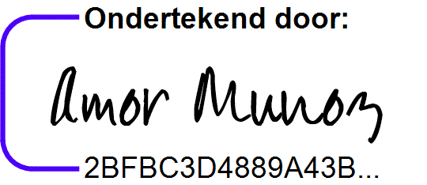

Amor Diego Muñoz Luis

Date: 17th December 2025
Form K(1)
COMPANIES ACT (CAP. 386)
Declaration of compliance with article 139 made by persons applying to become directors of a proposed company
Pursuant to article 139(1) and (5)
Name of Company: Sweetflips Holdings Limited
Delivered by: Nick Johannes Martinus Steeghs
_____________________________________________________________

To the Registrar of Companies:
I, (a) Nick Johannes Martinus Steeghs, the undersigned, hereby consent in terms of article 139(1) of the Companies Act, Cap. 386, to be appointed as a director of the said proposed company.

Furthermore, I hereby declare that in accordance with the provisions of article 139(5) of the Companies Act, Cap. 386, I am not aware of any circumstances which could lead to a disqualification from being appointed or to hold the office of director of a company. Effective date: (b) 17th December 2025

Signature ................................................
Nick Johannes Martinus Steeghs
Proposed Director

Dated this 17th day of December of the year 2025.
_____________________________________________________________

Finanzi Corporate Services Limited
Docusign Envelope ID: 32CA3F6E-4964-4C40-9F5B-2436D035C371
Capital Business Centre,
Entrance A, Floor 1,
Triq Taz-Zwejt,
San Gwann SGN3000
Malta

Company Reg No. C 89243
VAT No. MT2648 3907

Malta Business Registry
AM Business Centre
Triq il-Labour
Zejtun, ZTN 2401
Malta

Date:

Dear Sirs,

Re: Sweetflips Holdings Limited (Company-in-Formation) – Practitioner’s Certificate

We would like to confirm that we have received from the promoters of the private limited liability company-in-formation named in caption above (the “Company”) the total sum of EUR1,200 representing the value of fully paid up Issued Share Capital of the Company which is being held in our bank account for the time being for the sole benefit and interest of the Company and in order to satisfy the provisions of the Companies Act, Chapter 386 in respect of the paying up of the Issued Share Capital of the Company.

Accordingly, we undertake to release the funds remitted to us as aforesaid (after deduction of any bank charges) only:

- to the Company (once it is registered) in accordance with its instructions and subject to the Company’s instructions being evidenced in writing and issued by the duly authorised representative/s of the Company; or
- to the original remitter of the funds on written request of the remitting party but only if the Company has not at the time of the request been registered or insofar as the relevant registration documents have not already been filed for registration with the Registry of Companies.

As evidence of the deposits of funds in our account, we also attach herewith a copy of the relative deposit advice or statement issued by our bank in Malta referring to the funds remitted for share capitalization of the above-named Company “in-formation”.

Should you require any further clarification, please do not hesitate to contact the undersigned.

Yours faithfully,

Daryl David Caruana
Director
Finanzi Corporate Services Limited
www.finanzi.com.mt
info@finanzi.com.mt
(+356) 23889100

Docusign Envelope ID: 32CA3F6E-4964-4C40-9F5B-2436D035C371

POWER OF ATTORNEY

The undersigned, Danilo Haklander, a holder of Dutch passport number NNPHKJBF5 and residing at Emmy Andriessestraat 586, 1087 NE, Amsterdam, Netherlands, hereby appoints Finanzi Corporate Services Limited with company registration number C 89243 and having its registered office at Capital Business Centre, Entrance A, Floor 1, Triq Taz-Zwejt, San Gwann, SGN 3000, Malta (‘Finanzi Corporate Services Limited’) namely, Nazeli Aghalaryan, holder of Maltese identity card number 0207277A and Jessica Azzopardi, holder of Maltese identity card number 0538191M as Authorised Users to create, submit and sign electronically a Memorandum and Articles of Association document and all other documentation on my behalf as shareholder that may be necessary in connection with the formation of Sweetflips Holdings Limited, a company to be registered under the laws of Malta, and to subscribe on my behalf for six hundred (600) ordinary shares having a nominal value of one Euro (EUR 1) each and being fully paid up.

I, hereby undertake to approve, ratify and confirm whatsoever said attorney shall do or cause to be done in executing the powers hereby conferred.

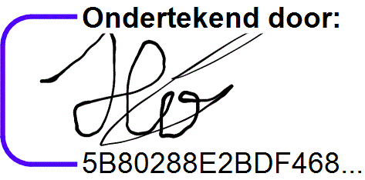

Danilo Haklander

Date: 17th December 2025

